NON-MEMBER BIRD HUNTS
Half-Day Hunt Packages  Our Half-Day Hunt Packages are a great way to experience upland bird hunting. You can have up to 4 people in the field and hunts typically last 3-4 hours. Packages include a professional guide with dogs to flush and retrieve the birds.  *Additional birds may be added to any package | 10 Bird Package $595.00  15 Bird Package $750.00  20 Bird Package $895.00  - No shot larger than 6  - Blaze orange is required in the field, hats available at the clubhouse $ 16.50  - Shells $15.00 (25 shells)  - Bird cleaning $5.00 (per bird)

Full-day Clay and Hunt Packages  These packages are great for anyone wanting to spend the whole day enjoying what we have to offer. They include birds, guide/dog, 100 clays, and lunch. These packages will typically last 6-8 hours.  *Additional birds may be added to any package  * Packages are based on 4 hunters  * Several itinerary options available | 10 Bird Package $850.00  15 Bird Package $995.00  20 Bird Package $1,140.00  - No shot size larger than 6  - Blaze orange is required in the field, hats available at the clubhouse $18.00  - Hunting ammo $15.00 (25 shells)  - Target ammo $10.00 (25 shells)  - Bird cleaning $5.00 (per bird)

All-Inclusive Hunt Package  Our All-Inclusive Hunt package has everything you need for upland bird hunting. It includes rental guns, shells, 50 clay targets, 15 pheasants, 5 chukar partridges, lunch, and bird cleaning. This package will typically last around 6 hours.  *Additional birds may be added to any package  * Packages based on 4 hunters  * Several itinerary options available | All-Inclusive Package $1195.00  Shells Included  Bird cleaning Included  - No shot size larger than 6  - Blaze orange is required in the field, hats available at the clubhouse $16.50

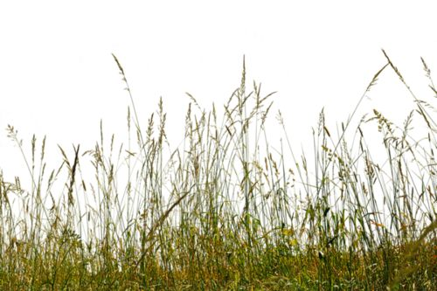
18000 Basswood Road * Three Oaks, MI 49128
Phone: (269)-756-6600 | Email: info@deercreekhuntclub.com
www.deercreekhuntclub.com

